Hong Kong: School Open Days 2019

If you’re currently in the process of choosing a new school, then you need to know these important dates. Here are Hong Kong’s international school open days and tours from October to December 2019

Do you have an Open Day at your school? Send us an email: es@itseducation.asia
Canadian International School Hong Kong
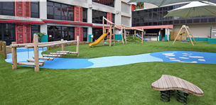
Day: Every Tuesday
Time: 10:00 am – 12:00 pm
Register: https://www.cdnis.edu.hk/admissions-enquiry-school-tours

Discovery Bay International School
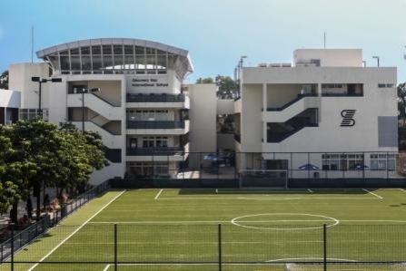
Early Years Campus Tours:
Dates: Oct 15, Oct 29, Nov 12, Nov 26, Dec 10, 2019
Time: 9:30 am – 11:00am
Register: https://www.dbis.edu.hk/399/admissions/tours-and-open-days

Primary/Secondary Campus Tours:
Dates: Nov 12, Nov 26, Dec 10, 2019
Times: 10:15am – 11:15am
Register: https://www.dbis.edu.hk/399/admissions/tours-and-open-days
French International School
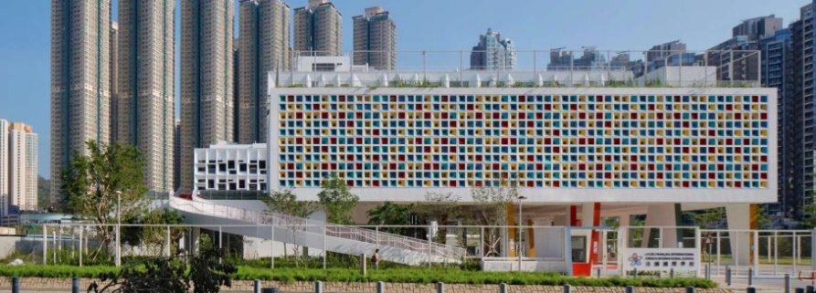
Tseung Kwan O Campus
Date: Oct 21, 2019
Time: 3:30 pm – 5:30 pm
Register: https://fishktalkandtourtko.youcanbook.me/
Primary School Tours:
Days: Thursdays at Tseung Kwan O campus & Fridays at Jardine’s Lookout campus
Register: https://fishk.youcanbook.me/
Secondary School Tours:
Tours are conducted on a request basis.
Email: inscriptions@lfis.edu.hk for French Stream
admissions@lfis.edu.hk for International Stream
____________________________________________________________________________________

German Swiss International School
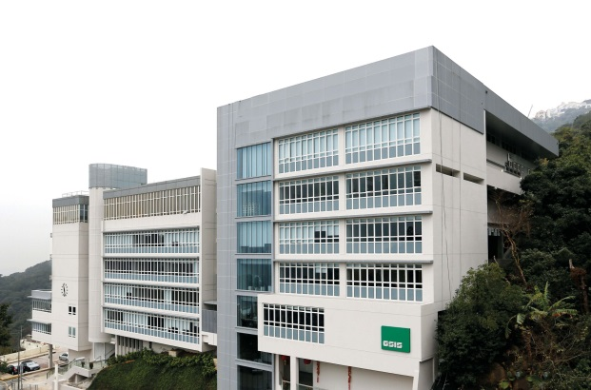
The Peak Campus (Year 2 – Year 6) Group Tour:
Dates: Nov 11, 2019; Dec 9, 2019
Time: 9:30 am – 11:00 am
Email: admissionprimary@gsis.edu.hk

Pok Fu Lam Campus (KG1, KG2, Year 1) Group Tour:
Dates: Nov 12, 2019; Dec 10, 2019
Time: 3:00 pm – 4:15 pm
Email: admissionkindergarten@gsis.edu.hk

Harrow International School
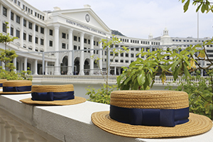
Lower School (K1 – Year 5)
Date: Feb 20, 2020, March 19, 2020, April 23, 2020, May 21, 2020
Time: 9:00 am – 11:00 am
Register: https://www.harrowschool.hk/admissions/visit-us/open-mornings

Upper School (Year 6 – Year 12):
Date: Oct 31, 2019
Time: 9:00 am – 11:00 am
Register: ttps://www.harrowschool.hk/admissions/visit-us/open-mornings

Hong Kong Academy
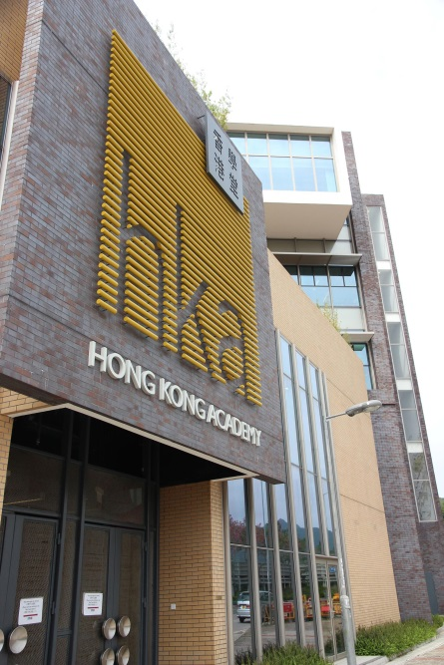

Early Years
Dates: Oct 17 & Nov 7, 2019
Time: 9:30 am – 11:00 am
Register: https://docs.google.com/forms/d/e/1FAIpQLSfi9HM0Op3EKyC1t7jg5olRoRwgnT2V0iHBVtPcIJRC2uEpzA/viewform

Secondary School
Date: Oct 31, 2019
Time: 9:30 am – 11:00 am
Register: https://docs.google.com/forms/d/e/1FAIpQLSdN-UubElbJbqpqqKxSMCnOEcfdOJyotW6Sd1KB3BdkZmcNUw/viewform

HKA Secondary School Open House
Date: Nov 28, 2019
Time: 6:30 pm – 8:00 pm
Register: admissions@hkacademy.edu.hk

Individual School Tours:
Days: Mondays and Thursdays
Email: admissions@hkacademy.edu.hk

Hong Kong International School
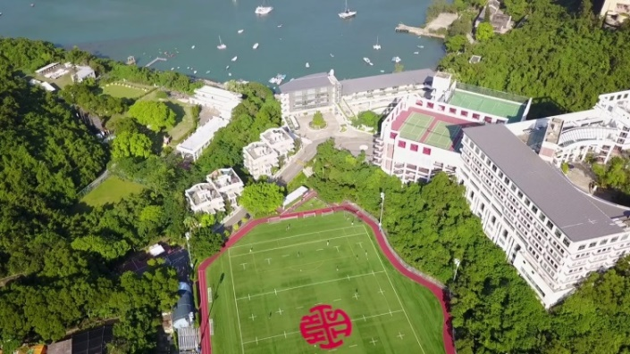
Lower Primary School (Reception 1 – Gr 2)
Day: Wednesdays
Time: 10:00 am – 11:30am
Register: https://docs.google.com/forms/d/e/1FAIpQLSdDWNF5ll8WdtFC5B-WFEaBqKsv9cq0ko8Bc5MQ7GaU-nsLiw/viewform

Upper Primary School (Gr 3 – Gr 5)
Day: Wednesdays
Time: 9:00 am – 10:30am
Register: https://docs.google.com/forms/d/e/1FAIpQLScDT8RjKxJafxiHT1nbFFmWIeHGr9DpgTWTpWtEP3TRDt-d1Q/viewform

Middle School (Gr 6 – Gr 8)
Day: Tuesdays
Time: 11:30am -1:00
Register: https://docs.google.com/forms/d/e/1FAIpQLSezIV4jRNtWQ_NLzwkBUOR0sj_hne4e7X1MnZNUy0mdt83UGQ/viewform

High School (Gr 9 – Gr 12)
Day: Tuesdays
10:00 am – 11:30am
Open House
Date: Nov 28, 2019
Time: 9:00 am – 12:00 pm
Register: https://docs.google.com/forms/d/e/1FAIpQLSf6BHxUCTdJsGpCCkpwrCj7BeJXrQo-KzqVhUH48sM8OHhk7Q/viewform

International College Hong Kong
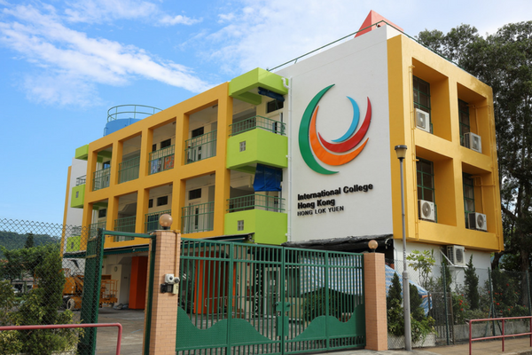
Register here to book a tour: https://www.ichk.edu.hk/home/join-our-community/book-a-tour/
_____________________________________________________________________________________

The ISF Academy
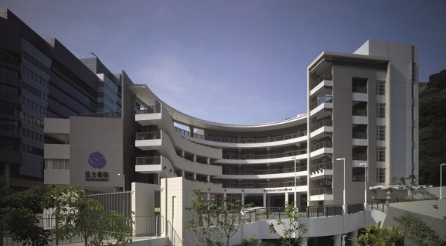
Primary Admissions Briefing Session and School Tour (Offered in English, Putonghua and Cantonese)
Date: Dec 11, 2019
Time: 10:15 am – 12:15 pm
* Register: need to set up Friends of The ISF account to register for ISF events
https://admissions.isf.edu.hk/

Secondary Admissions Information Session and School Tour (Offered in English, Putonghua and Cantonese)
Dates: Nov 7 & Nov 21, 2019
Time: 9:30 am – 11:00 am (English and Cantonese Tour)
Time: 10:30 am – 12:00 pm (Putonghua Tour)
* Register: need to set up Friends of The ISF account to register for ISF events
https://admissions.isf.edu.hk/

Island Christian Academy
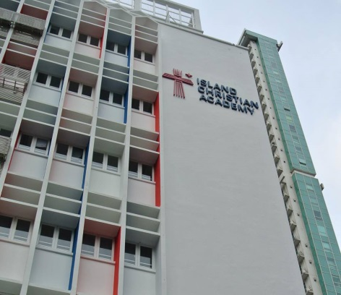
School Tours
Day: Fridays
Time: 8:30 am – 10:00am
Register: https://docs.google.com/forms/d/12lCcFCeqg2BseW2HKWSsgOshiWrJ6kfis4DaqjNMiTM/viewform?edit_requested=true

Kellett School
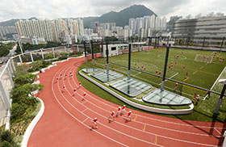
Pok Fu Lam Prep
Day: Tuesdays and Thursdays
Time: 9:10 am – 11:00am
Kowloon Bay Prep
Day: Mondays and Wednesdays
Time: 10:30 am – 12:00pm
Kowloon Bay Senior
Day: Mondays and Wednesdays
Time: 9:00 am – 10:30am
Register: https://docs.google.com/forms/d/e/1FAIpQLSfsF216DjxOTPDU4HXH6GEBt0c8ANzQFe7J9FxpSTJma32eKw/viewform
Malvern College Hong Kong
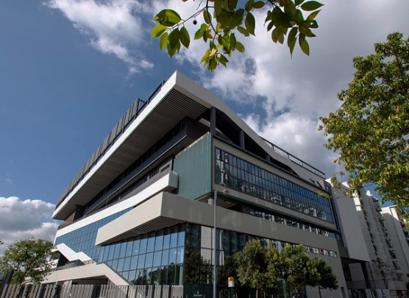
Open Morning
Date: October 30, 2019
Time: 8:30am – 12:00 pm
Register: https://bit.ly/2pk3OCB

Mount Kelly Hong Kong
Information Session – Meet the Specialist Teachers
Venue: G/F, 152 Austin Road, Tsim Sha Tsui, Kowloon, Hong Kong
Date: Tuesday, 5 November 2019
Time: 9:30am to 11:00am
Register: https://www.mountkelly.edu.hk/events/Meet-our-Specialist-Teachers.aspx?ECatg=c4a7d18d083145b5a4fdd8788cfd4853&Mode=Day&Date=5/11/2019

Nord Anglia International School
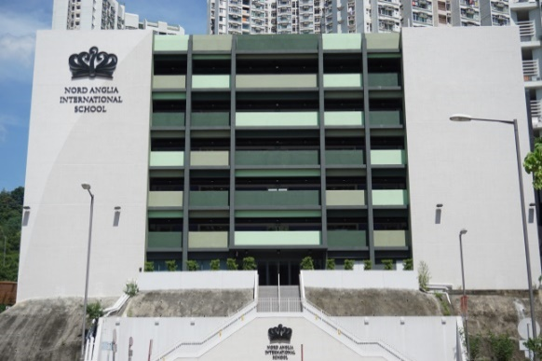
Lam Tim Campus
Dates: Nov 1, Nov 15, Nov 22, Dec 6, 2019
Time: 8:45 am – 10:00 am
Register: https://www.nordangliaeducation.com/our-schools/hong-kong/admissions/campus-tours
Tai Tam Campus
Dates: Oct 23, Oct 30, Nov 6, Nov 20, Nov 27, Dec 4, 2019
Time: 9:00 am – 10:00 am
Register: https://www.nordangliaeducation.com/our-schools/hong-kong/admissions/campus-tours
Sai Kung Campus
Dates: Oct 23, Oct 30, Nov 6, Nov 13, Nov 20, Nov 27, Dec 4, 2019
Time: 9:00 am – 10:00am
Register: https://www.nordangliaeducation.com/our-schools/hong-kong/admissions/campus-tours
_____________________________________________________________________________________
Norwegian International School
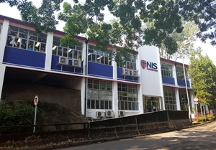
School Tours:
Day: Thursday
Time: 9:45 am – 10:45
Register: https://www.nis.edu.hk
Open Day:
Date: Oct 19, 2019
Time: 10:30 am – 1:30am
Register: https://www.nis.edu.hk

Shrewsbury International School Hong Kong
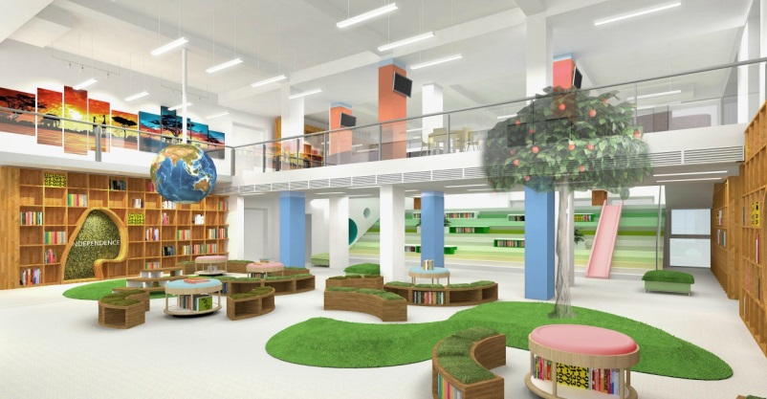
Dates: Oct 30, Nov 6, Nov 13, Nov 20 & Nov 27, 2019
Time: 10:00 am – 11:00 am
Register: https://www.shrewsbury.edu.hk/events-community/events/talk-tour
Weekend Campus Tour:
Date: Nov 16, 2019
Time: 10:30 am – 11:30 am
Register: https://www.shrewsbury.edu.hk/events-community/events/talk-tour
_____________________________________________________________________________________
Singapore International School
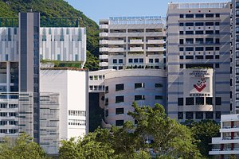
Dates: Oct 18 & Oct 30, 2019
Time: 10:15 am – 11:45 am
Register: https://www.eventbrite.hk/e/sishk-ay201920-campus-tours-tickets-65081441343

Small World Christian Kindergarten
Dates: Oct 24, Nov 1, Nov 8, Nov 15, Nov 21, Nov 28, Dec 6, Dec 13, 2019
Time: 9:30 am -11:00am
Register: https://docs.google.com/forms/d/e/1FAIpQLSfdwqpkBhxG9r1o_AFEeI2jMheNlPxioASbWt73mrVJB4uhjg/viewform

Stamford American School
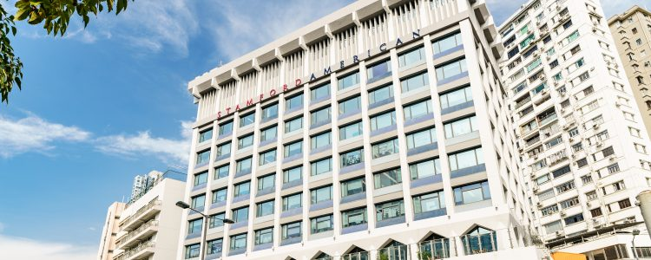
Dates: Oct 31 & Nov 7, 2019
Time: 12:45 pm – 1:45pm
Register: https://www.sais.edu.hk/admissions/visit-stamford/school-tour-online-enquiries/
_____________________________________________________________________________________
Yew Chung International School
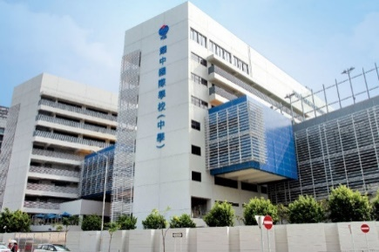
Early Childhood Education Information Sessions
Date: Oct 17, 2019
Time: 2:30 pm – 3:30 pm
Register: https://www.ycis-hk.com/en/school-life/upcoming-events/407-early-childhood-education-information-session-march-19-2020
Primary Information Sessions
Date: Nov 14, 2019
Time: 3:15 pm – 4:15 pm
Register: https://www.ycis-hk.com/en/school-life/upcoming-events/409-primary-information-session-eng-2
Secondary Information Sessions
Date: Nov 8, 2019
Time: 4:00 pm – 5:30 pm
Register: https://www.ycis-hk.com/en/school-life/upcoming-events/408-sec-info-session-2019
School Tours
Register here to join one of their tours: https://www.ycis-hk.com/en/admissions/visit-our-school

